Chapter 3, Problem 50.

Use mesh analysis to find the current i_{o} in the circuit in Fig. 3.95.

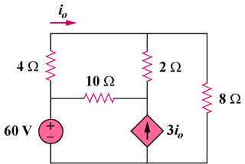

35 V

Figure 3.95
For Prob. 3.50.

